Q1.
B: If statement
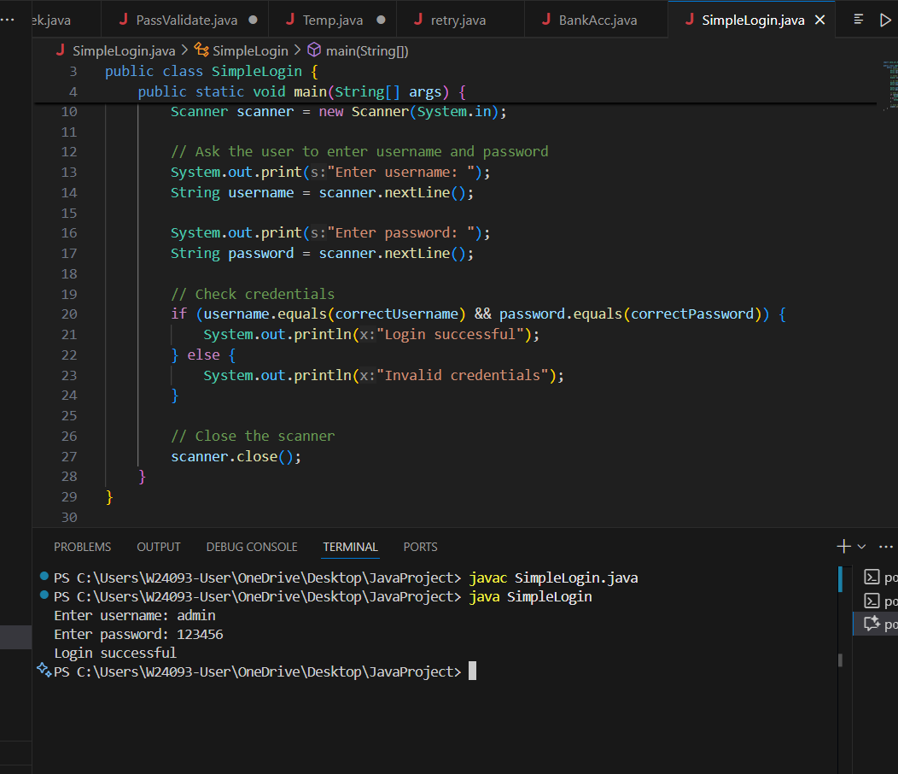

Reason: if statement:
Checks a condition once (true/false).
Perfect for verifying username and password.
Simple and direct implementation.

Q2.
A: if-else if-else statement
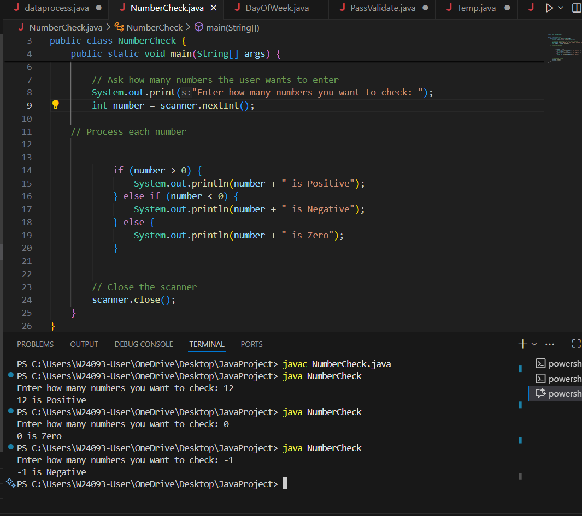

Reason: Handles multiple conditions (>0, <0, ==0)
Executes different actions based on the condition

Q3.
C: Switch statement
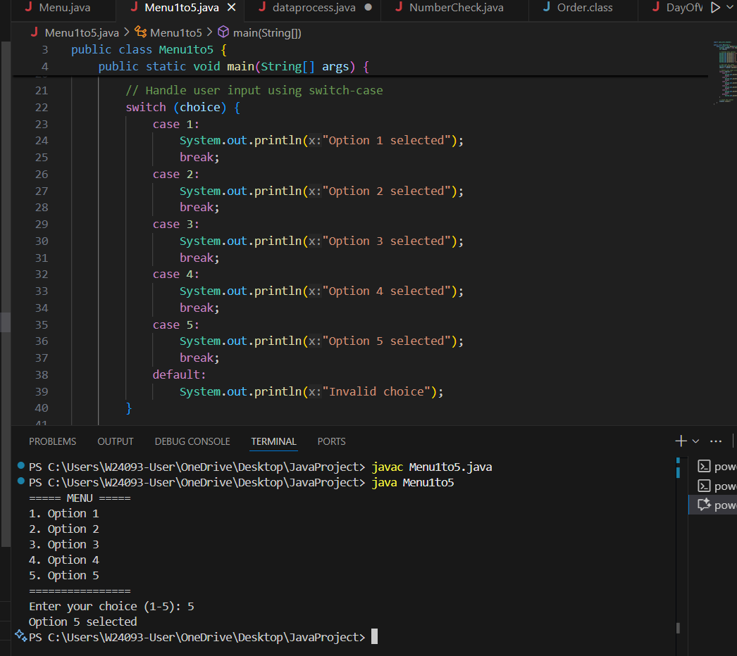

Reason: switch statement is suitable to choose from multiple discrete options based on a single value.

Q4.
C: While loop
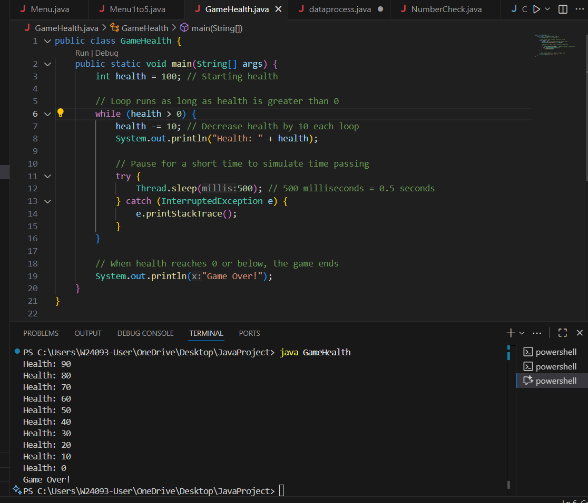

Reason: while loops are used to repeat actions as long as a condition is true.

Q5.
B: While loop
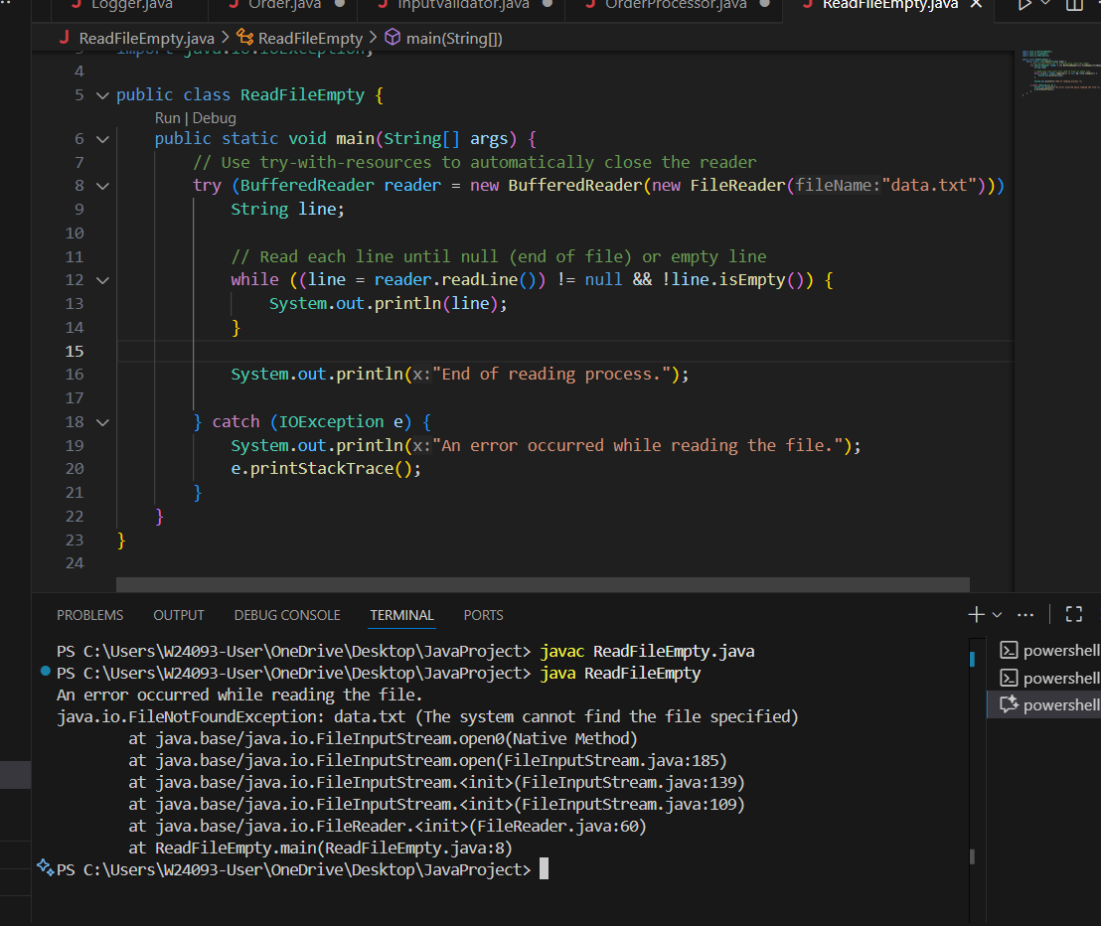

Reason: while loops are ideal for repeating an action until a certain condition becomes false.

Q6.
B: do-while loop
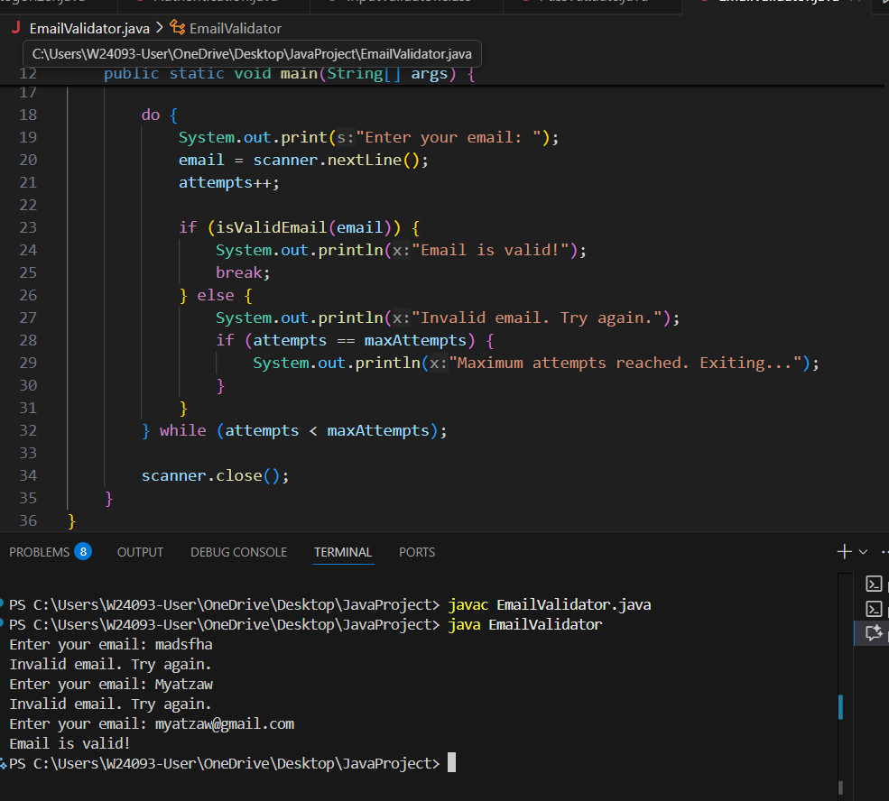

Reason: do-while loops execute the loop body at least once before checking the condition.

Q7.

B: if-else if-else statement
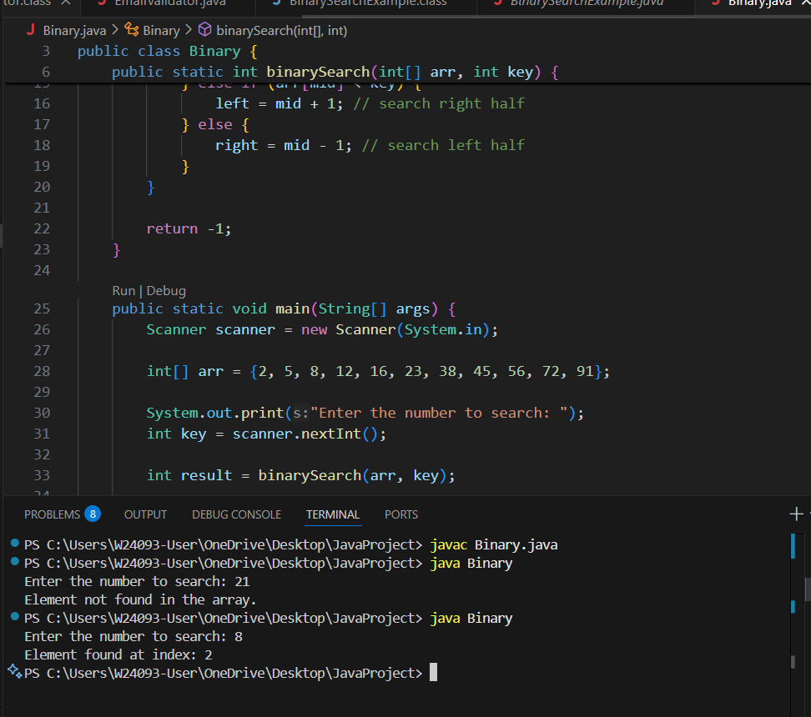

Reason: It is used to check multiple conditions in sequence.

Q8.

B: Switch statement
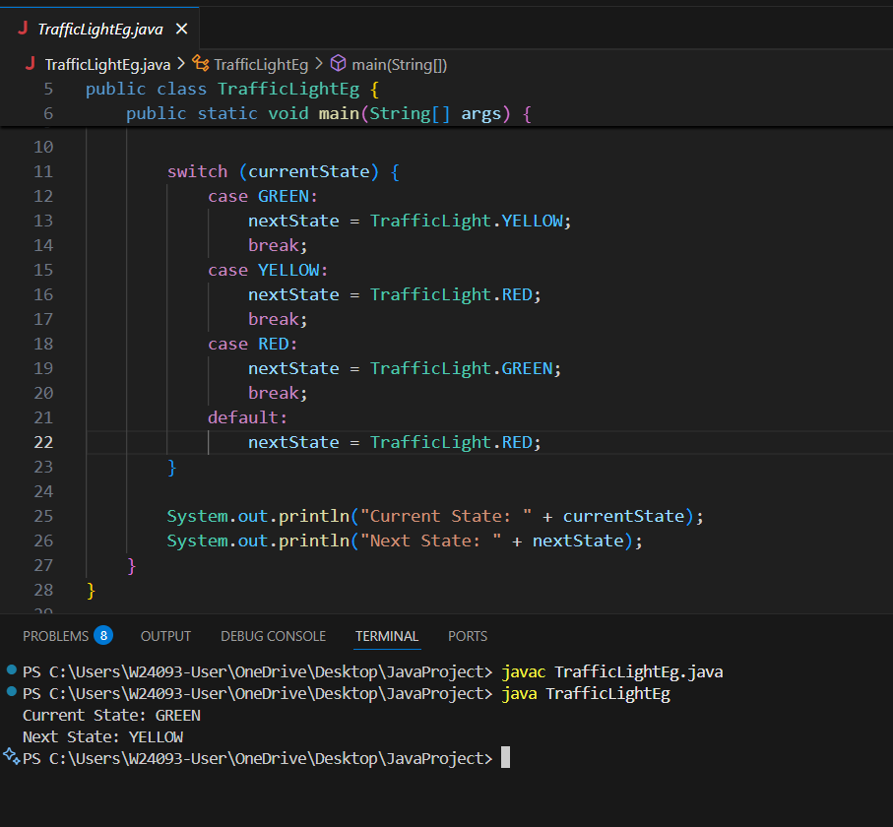

Reason: switch is ideal for choosing between cases, fixed states.

